1. Create Table Name : Student and Exam
Table 1 : Student

CREATE TABLE STUDENT(
Rollno INT PRIMARY KEY AUTO_INCREMENT NOT NULL,
Name VARCHAR(40),
Branch VARCHAR(50)
);
INSERT INTO STUDENT(Rollno,Name,Branch) VALUES
(1,"Udit","Information Technology"),
(2,"Jay","Computer Science"),
(3,"Kriti","Computer Science");

SELECT * FROM STUDENT;
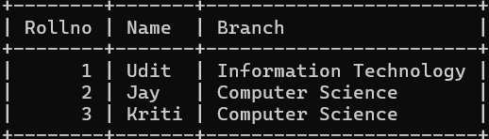

Table 2 : Exam

CREATE TABLE Exam(
EnrollmentNo INT,
FOREIGN KEY(EnrollmentNo) REFERENCE STUDENT(Rollno),
S_code VARCHAR(10),
Marks INT,
P_code VARCHAR(10)
);
INSERT INTO Exam(EnrollmentNo,S_code,Marks,P_code) VALUES
(1,"IT11",50,"IT"),
(1,"IT12",60,"IT"),
(2,"CS101",66,"CS"),
(2,"CS102",70,"CS"),
(3,"CS101",45,"CS"),
(3,"CS102",50,"CS");

SELECT * FROM STUDENT;
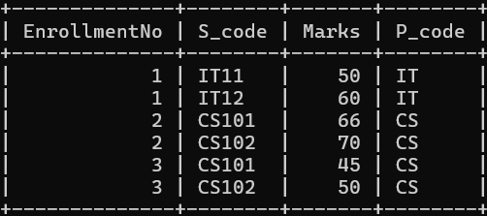

SELECT STUDENT.Rollno, STUDENT.Name, STUDENT.Branch, Exam.S_code, Exam.Marks, Exam.EnrollmentNo FROM STUDENT INNER JOIN Exam ON STUDENT.Rollno=Exam.EnrollmentNo;
